Software.
Software:
      - Fiji: https://imagej.net/Fiji including bio-format importer and hdf5 plugin,
      - XUVtools stitching software (Emmenlauer, M. Et al., 2009),
      - image processing and analysis software:
(https://lmb.informatik.uni-freiburg.de/lmbsoft/iRoCS/
Manual: https://lmb.informatik.uni-freiburg.de/lmbsoft/iRoCS/walkthrough.html
Microscopic images were imported to Fiji through bio-format importer and saved as .hdf5 format. Each tile should be saved separately as separate .hdf5 file.
If necessary, tiles should be stitched by using XUVtols stitching software (version 1.7.0) (http://www.xuvtools.org/doku.php?id=download) (M Emmenlauer et al., 2009).
Image processing.
Add file to the project-> select files you want to stich-> Run stitcher-> ignore the current coordinates ->Run->Save as .hdf5 (do not use save the project; default saving option is .ims). When you scan simultaneously 2-3 channel, it is highly recommended to save position of the tiles from the first channel (by click position editor and mention positions of each tile after stitching). When you stitched the second-third channels, use the same tiles position. In the case you stitched all channels automatically, you may have a slight differences in overlapping volume, what will affect your analysis in the future).
Alternatively, one can use Fiji 3D stitching option, but it allows to stitch only 2 tiles simultaneously and require much higher memory resources.
Thereafter image must be imported to organ analysis software (https://lmb.informatik.uni-freiburg.de/lmbsoft/iRoCS/).
Channel-> import channel-> Ok
Important notice: IRoCS Toolbox is developed inside Freiburg University, hence its binaries are not signed for Windows SmartScreen. However, it is safe to run labelling.exe or other released executables, and their source code can be found on GitHub (https://github.com/lmb-freiburg/iRoCS-Toolbox). If Windows SmartScreen displays an information window when running labelling.exe, saying "Windows protected your PC", you can click "More Info", and then "Run Anyway".
For better visualization, normalize button must be clicked and signal should be adjusted by changes to gamma, alpha and choosing best color.
2-3-4 channels can be imported one by one.
Thereafter corresponding plugin should be applied: Segmented Root or Detect Nuclei or.
Detailed protocol for segmentation step by step:
1. Open .lsm/.tiff file in Fiji: Plugins -> Bio Formats -> Bio-Formats Importer -> select all relevant series -> OK
2. Stitch: Plugins -> Stitching -> deprecated -> 3D Stitching -> select first and second series -> OK, then repeat and select combined series and the third one, repeat until all the series are stitched together.
3. Export to HDF5: Plugins -> HDF5 -> Save to HDF5 (new or replace)
To perform segmentation in iRoCS:
NOTE1: you can visualize every step, View>Log.
NOTE2: make sure that you save your images in every step that you made a modification; the correction can NOT be recovered.
NOTE3: It is recommended to save the file after labeling it with a new name. After channel rename, both channels have been saved, which is significant increases the file size.
1. Load HDF5 file: Channel -> Import Channels -> select file -> select t0/channel0 channel
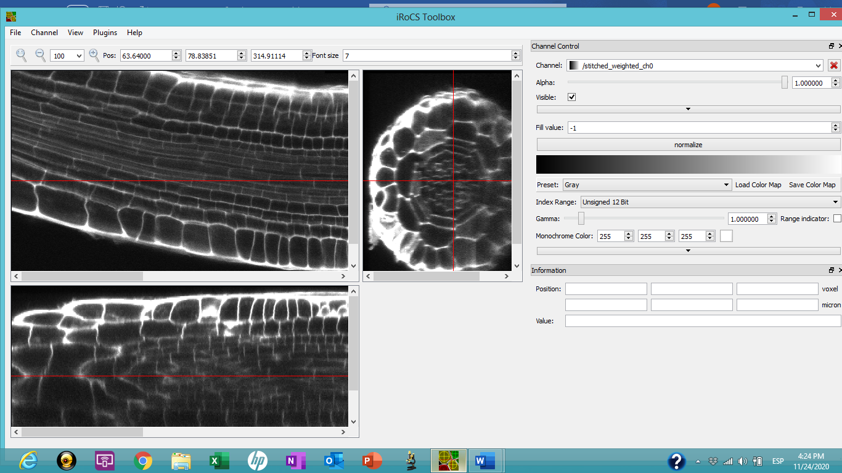

2.Plugins -> C01 Segment root -> for (THIS TYPE OF ROOT) adjust processing element size to 0.6-0.7 range for reasonable runtime and results. Smaller element size will produce better segmentation but consumes significantly more time and computational resources.
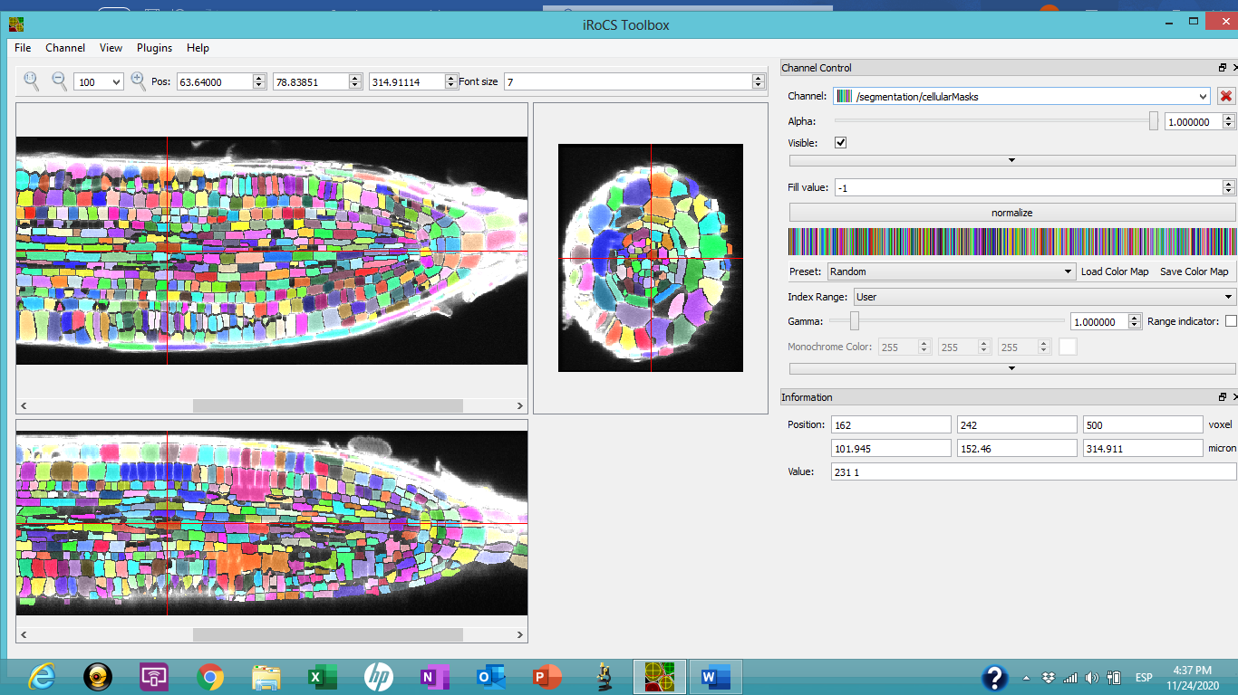

3. Optionally remove irrelevant segments: while holding Shift, right-click on black background, then left-click on the segments to remove.
NOTE: this step is important if in your images have particles or undesirable elements in your samples. Removing this issue helps to get a faster analysis and clear images. For remove this issue move the bars and red lines in all the images and make sure to do not have one.
4. Add new QC marker: Channels -> New annotation channel -> optionally name it QC
5. Attach axis: Plugins -> C02 Attach iRoCS to segmented cells -> select t0/segmentation/cellularMasks channel as segmentation channel, previously created channel with marker as QC channel.
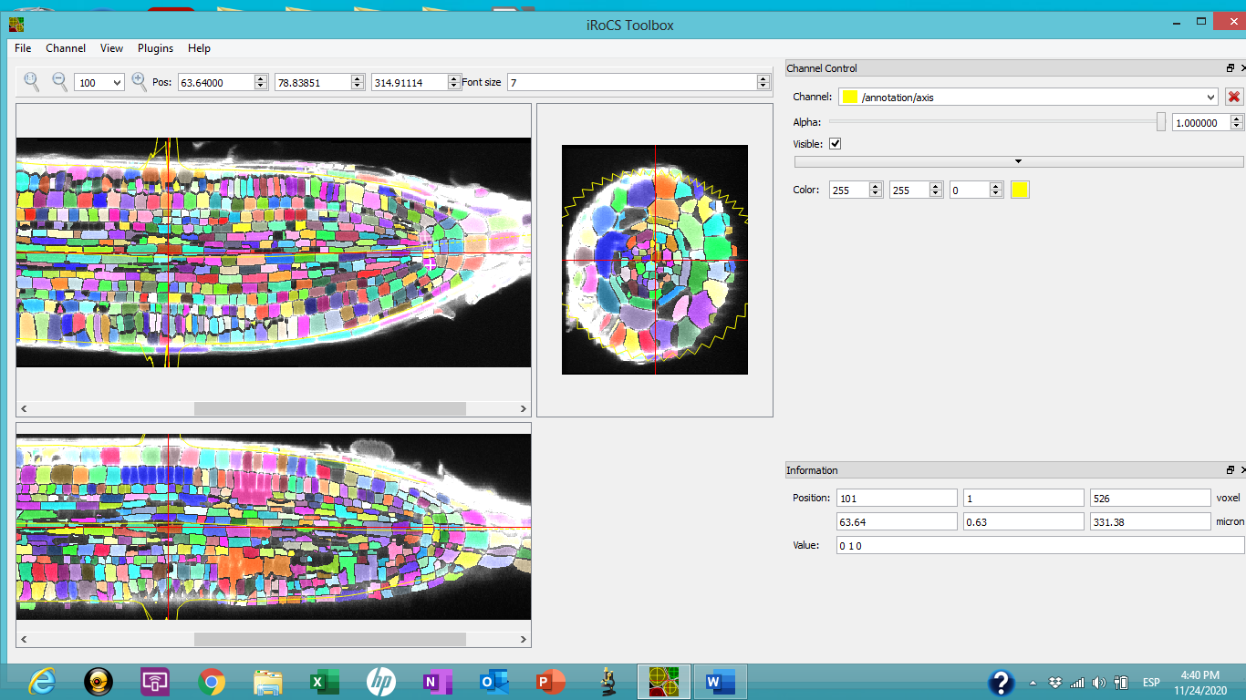
6. Convert mask to marker by using corresponding plugin: choose connected component labelling and choose cells as marker type, start processing.
7. Assign labels: in the window channel control you can move the channel “/cellularMasks” and after “/annotation/segmented” and select “visible”. Then in view type choose a “label” and operation choose “label marker”. In section “marker presets” choose a label marker design or assign a new one and choose the cell type for label.
Every time that you click over you selected cells, they will have a number and the contour of the cell the color that you selected.
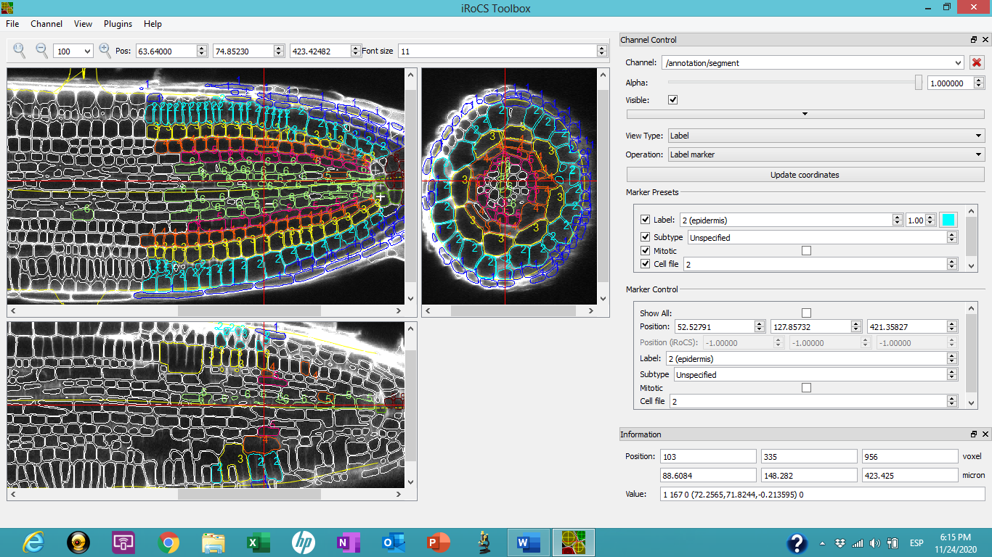

8. Export results. Channel>Export annotation channel to CSV.
Make correction of the layers.
Detailed protocol for nuclei analysis step by step:
1. Open lsm file: Plugins -> Bio Formats -> Bio-Formats Importer -> select all relevant series -> OK
2. Stitch: Plugins -> Stitching -> deprecated -> 3D Stitching -> select first and second series -> OK, then repeat and select combined series and the third one, repeat until all the series are stitched together.
3. Export to HDF5: Plugins -> HDF5 -> Save to HDF5 (new or replace)
To perform nuclei detection in iRoCS:
1. Load HDF5 file: Channel -> Import Channels -> select file -> select t0/channel0 channel
2. Plugins -> 01 Detect Nuclei -> as a model use corresponding file from web-site.:
3.Plugin -> 01 Label Epidermis -> as a model use file from website (Arabidopsis only):
4. Add QC marker: Channels -> New annotation channel -> optionally name it QC
5. Attach iRoCS: Plugins -> 03 Attach iRoCS -> select annotation channel as annotation/detector and as QC previously created channel with marker as QC channel.
5: Assign labels: Plugins -> 04 -> select model file (corresponding model from website), "Layer assignment " file (direct link https://lmb.informatik.uni-freiburg.de/lmbsoft/iRoCS/wt-model.rf.h5)
Make correction of the layers.
It is advised to save results of each intermediate step to separate file in case anything goes wrong.
Thereafter you can export annotation channels to .csv and process in excel. In excel file you will have X,Y.Z as position of center mass of the cells in whole frame; label as cell file name; distance from QC in µm, radial distance in µm, radial distance; subtype; mitotic; cell file and cell volume (for segmentation only).
Corrections of the segmentations and nuclei labeling.
Model for segmentation, nuclei detection and layers labelling were created for high quality images for 4 days old Arabidopsis plants. If you image quality or age of the plants (species) are different, you must use manual corrections. Segmentation corrections can be performed in version 1.2.4 what allow to correct over-segmented cells and correct layers.
Nuclei corrections can be done in any version: choose annotation channel, label marker and changes manually layer label.
Data extraction/presentation.
After data extraction each cell/nuclei have a 3 basic coordinates: distance from QC, radial distance and radians (un rolled organ). We would suggest to use in the graphical presentation un-rolled root, ea. radians on x axis and distance from QC as y-axis. Volume can be embedded as third coordinates for the cells as well as for nuclei.
Statistical analysis.
The platform allows us to extract at least all parameters from 5000 cells from Arabidopsis and 30000 cells for large roots (tobacco, tomato, millet). In the commonly used method authors analyzed maximal 100 cells per root. When they mention 10 roots, it mean that analyzed 1000 cells, in many case less quantitative. While using platform, one has to scan 5-6 typical root and can perform analysis 4 of them to get statistically significant data to comparison with 2D statistics.

